### Lab11 – Inverse Kinematics

# Content

Table of Contents

1. Content 1

2. Learning objectives 1

2.1. Exam objectives 1

2.2. Supportive objectives 1

3. Exercises 2

3.1. Basic exercises : Angle Calculation 2

3.2. Exercises : CCD 4

3.3. Exercises : FABRIK 8

4. References 11

4.1. Basics 11

# Learning objectives

## Exam objectives

By the end of this lab you should be able to (pen and paper):

* Determine a signed (oriented) angle by using vectors
* Rotate a vector (over an signed angle) by using the rotation matrix
* Calculate the main steps, implementing the CCD algorithm (on an simplified bone structure) for few iterations

We advise you to **make your own summary of topics** which are new to you.

## Supportive objectives

### Self-support by GeoGebra Online

More specifically related to the above you should in **GeoGebra Online** <https://geogebra.org/classic>

* Determine a signed (oriented) angle by using vectors
* Rotate a vector (over an signed angle) by using the rotation matrix
* Calculate the main steps, implementing the CCD algorithm (on an simplified bone structure) for few iterations

# Exercises

Dependent of the lab session you may work individually or teamed (organized by the lab attendant). In either case make sure that throughout the course of this lab, you backup sufficiently your solution file on your local machine as

**1DAExx-0y-name1**(+name2+name3).GGB given **xx**=groupcode, **0y**=labindex

## Basic exercises : Angle Calculation

For all underneath exercises do at least one pen and paper attempt in your own workbook, before checking your results in GeoGebra. In case of mismatches between your handwritten results and GeoGebra’s output, do not hesitate to seek assistance by your Lab attendant, as you are owner of your own learning.

**Exercise 1:**

Assuming a ship moving along the vector vf. The world position of the different elemenst are specified below.

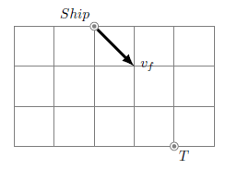

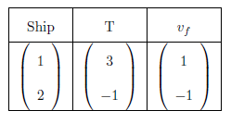

1. Calculate the signed angle between the vector vf and the vector $\vec{Ship T}$. The sign of the angle can be found by using a cross and dot-product.
$$\vec{ShipT} ∙v_{f}=\left(\begin{aligned}2 \\ -3\end{aligned}\right)∙\left(\begin{aligned}1 \\ -1\end{aligned}\right)=5$$

$$\left(\begin{aligned}2 \\ -3 \\ 0\end{aligned}\right)×\left(\begin{aligned}1 \\ -1 \\ 0\end{aligned}\right)=\left[\begin{matrix}\hat{e_{x}} & \hat{e_{y}} & \hat{e_{z}} \\ 2 & -3 & 0 \\ 1 & -1 & 0\end{matrix}\right]=\left(\begin{aligned}0 \\ 0 \\ 1\end{aligned}\right)$$

$$angle=cos^{-1}\left(\frac{5}{\sqrt{13}⋅\sqrt{2}}\right)={11.31}^{°}$$

2. Calculate a rotation matrix that will rotate the vector vf over the calcu-

lated angle. Apply this rotation matrix to the vector vf.

c) Check your results in Geogebra. Geogebra has a tool that can measure

the angle between three points and a tool that can rotate a point or vector

around another point.

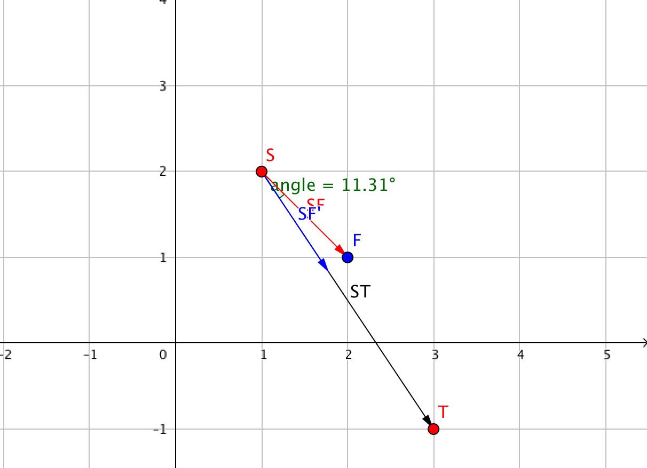

**Exercise 2:**

Assuming a ship moving along the vector vf. The world position of the different elements are specified below.

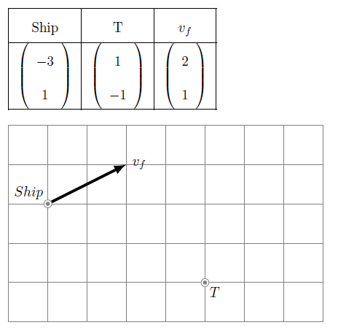

1. Calculate the signed angle between the vector vf and the vector .

b) Calculate a rotation matrix that will rotate the vector vf over the calcu-

lated angle. Apply this rotation matrix to the vector vf.

c) Check your results in Geogebra. Geogebra has a tool that can measure

the angle between three points and a tool that can rotate a point or vector

around another point.

**Exercise 3 (finalize at home)**

Assuming a ship moving along the vector vf. The world position of the different elements are specified below.

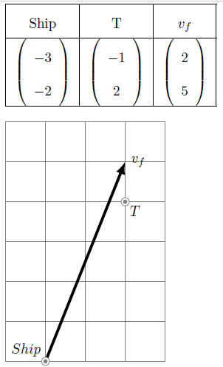

1. Calculate the signed angle between the vector vf and the vector .

b) Calculate a rotation matrix that will rotate the vector vf over the calcu-

lated angle. Apply this rotation matrix to the vector vf.

c) Check your results in Geogebra. Geogebra has a tool that can measure

the angle between three points and a tool that can rotate a point or vector

around another point.

## Bridging Exercises : Continuous Cyclic Descent

In this section you will calculate some of the steps that are necessary to im- plement the CCD algorithm. We start with a simple setup with two joints, an effector E and a target T, guided by the **angular error metric** only.

### Exercise 1

Given the following joint system and target :

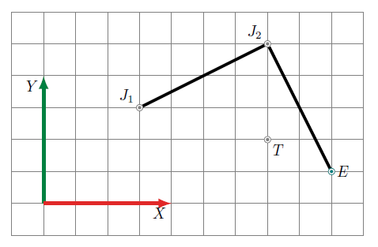

The coordinates for the joints, effector and target are :

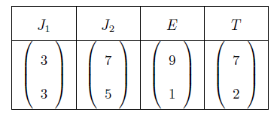

### First iteration

Calculate the **signed** **angle** between the vectors and .

Rotate the point E around the point J2 with an appropriate matrix.

As always, check your result in Geogebra before you continue.

**Next**, repeat the same process but now with J1 as the center of rotation. In other words, calculate the signed angle between the vectors $\vec{J1 E'}$ and $\vec{J1 T}$.

Rotate the point E’ around the point J1 with the correct rotation matrix.

As always, check your result in Geogebra before you continue.

Compare the new distance between target and effector to the initial Is this distance okay or not?

### Second iteration

Repeat the process as outlined in the first iteration. Check if the effector E comes closer to the target T.

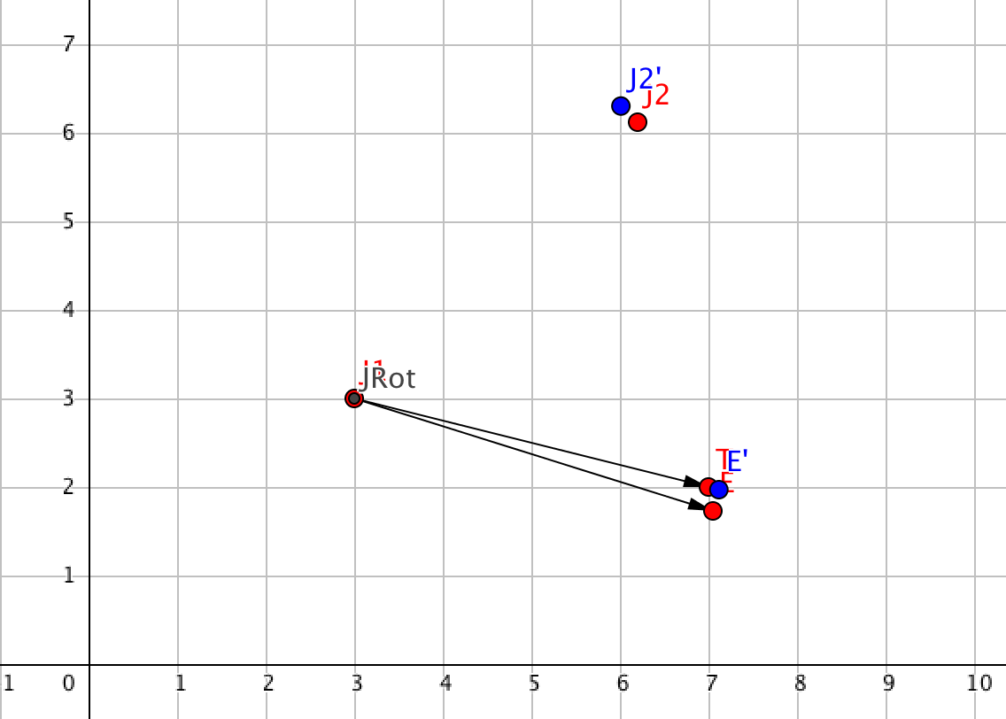

### Exercise 2

Given the following joint system and target :

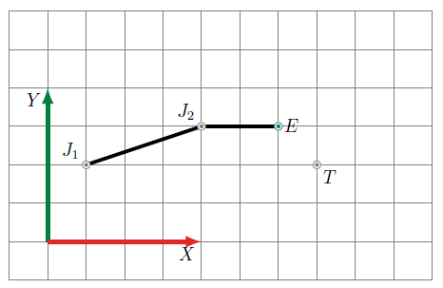

The coordinates for the joints, effector and target are :

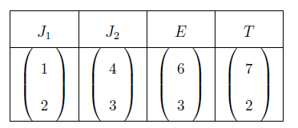

### First iteration

Calculate the **signed** **angle** between the vectors and .

Rotate the point E around the point J2 with a correct matrix.

As always, check your result in Geogebra before you continue.

**Next**, repeat the same process but now with J1 as the center of rotation. In other words, calculate the signed angle between the vectors $\vec{J1 E'}$.and $\vec{J1 T}$.

Rotate the point E’ around the point J1 with a correct matrix. As always, check

your result in Geogebra before you continue.

Compare the new distance between target and effector to the initial Is this distance okay or not?

### Second iteration

Repeat the process as outlined in the first iteration. Check if the effector E comes closer to the target T.

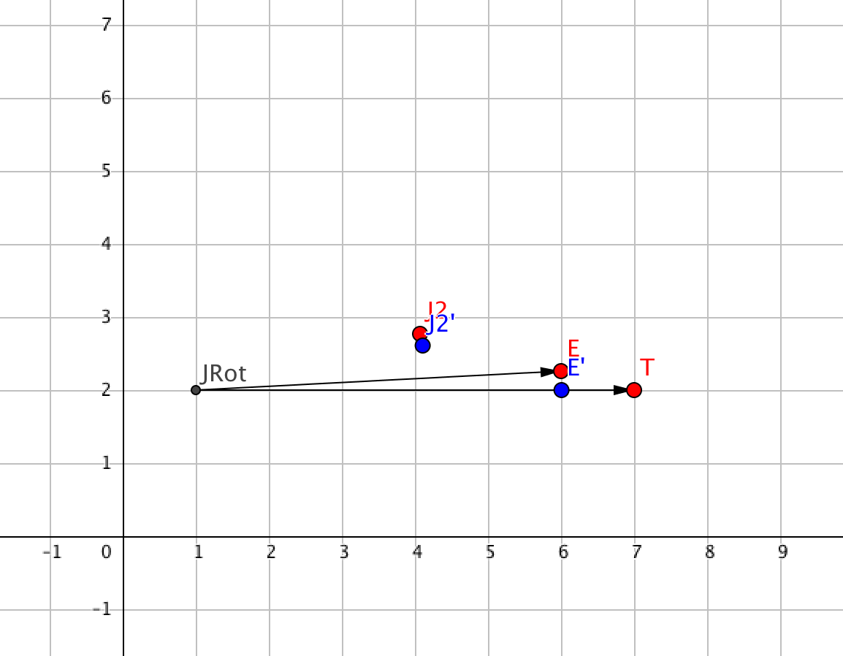

## Bridging Exercises: FABRIK

In this section you will implement the FABRIK algorithm. We start with a simple setup with two joints, an effector E and a target T, guided by the **angular error metric**.

### Exercise 1

Given the following joint system and target :



The coordinates for the joints, effector and target are :



### Step1 :

To implement the FABRIK algorithm calculate the **signed** **angle** between the vectors and . *(identical to 3.2.1)*

Rotate the point E around the point J2 with a correct matrix.

As always, check your result in Geogebra before you continue.

### Step 2 :

Calculate the free vector given E’ the rotation image point of E. Translate the link [J2E’] by vector with a correct matrix, wich means point T coincides with the effector and the new position of J2 becomes J2’. Check your results with geogebra.

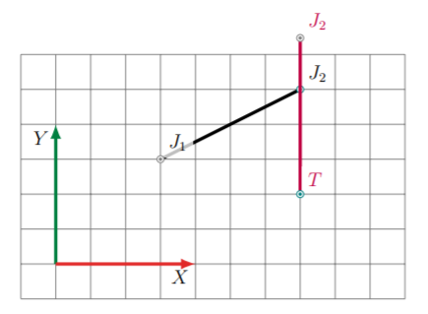

### Step 3 :

Calculate the signed angle between the vectors and .

Rotate the point J2 around the point J1 with a correct rotation matrix and J2’’ as the rotation image point. Calculate the vector J2’’J2’ and shift the link [J1 J2’’] so that J2’’ coincides with J2’ and find the new position of J1

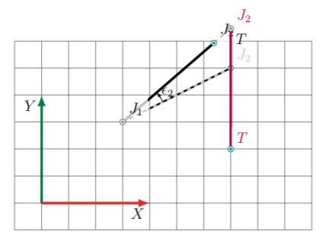

### Exercise 2 (homework)

Given the following joint system and target :



The coordinates for the joints, effector and target are :



### Step1 :

To implement the FABRIK algorithm calculate the **signed** **angle** between the vectors and . *(identical to 3.2.1)* Rotate the point E around the point J2 with a correct matrix. As always, check your result in Geogebra before you continue.

### Step 2 :

**C**alculate the free vector given E’ the rotation image point of E. Translate the link [J2E’] by vector with a correct matrix, wich means point T coincides with the effector and the new position of J2 becomes J2’. Check your results with geogebra.

### Step 3 :

Calculate the signed angle between the vectors and . Rotate the point J2 around the point J1 with a correct rotation matrix and J2’’ as the rotation image point. Calculate the vector J2’’J2’ and shift the link [J1 J2’’] so that J2’’ coincides with J2’ and find the new position of J1

# References

## Basics

### English maths dictionary

<http://www.mathwords.com>

### Inverse kinematics basics

<https://www.youtube.com/watch?v=MvuO9ZHGr6k&gl=BE>